**Week 4**

**Simulation-HTTP**

**1.Learning objectives:**

* get exposed to HTTP protocol used in application layer.
* Understand how HTTP and TCP work when a client browses.

**2.Topology**

One client and one server directly connected.

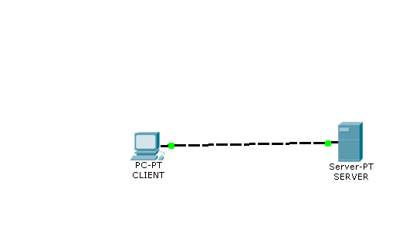

**3.Conduction**

**PartA.**

|  |  |  |  |
| --- | --- | --- | --- |
|  | **do** | **Observe** | Write down / Answer the question |
| 1 | **Select ‘Real mode’** |  |  |
| 2 | Set up the network as shown in the diagram |  |  |
| 3 | Configure IP addresses  Client : 10.10.10.1/8  Server : 10.10.10.2 |  |  |
| 4 | Click on CLIENT and select DESKTOP |  |  |
| 5 | Click on WEB BROWSER | Browser page |  |
| 6 | Enter 10.10.10.2 in the URL field | Text displayed | **Copy the first sentence of the output.**  **Ans** |
| 7 | Click on the text ‘small page’ | Text displayed | **Output?**  **Ans :** |
| 8 | Click on the text ‘image’ |  | **What is displayed?**  **Ans :** |

**Part B.**

|  |  |  |  |
| --- | --- | --- | --- |
|  | **Do** | **Observe** | Write down/Answer the question |
| 1 | **Click ‘Power Cycle Devices’**  **Select ‘Simulation Mode’** |  |  |
| 2 | Repeat steps 4,5 & 6 of PartA  [ Browse 10.10.10.2] |  |  |
| 3 | Use ‘Auto Capture Mode’ and wait until the home page is displayed. |  |  |
| 4 | Event list | **All events** | **Copy all events and analyze** |
|  |  |  | **What is the first set of protocols executed**  **Ans :** |
|  |  |  | **What is the second set of protocols executed**  **Ans :** |
|  |  |  | **Total time taken to complete all protocols**  **Ans :** |
|  |  |  | **What is the last set of protocols executed**  **Ans :** |
| 5 |  | **Analyse HTTP** |  |
|  | In the event list, filter all the protocols and retain only HTTP using ‘Edit filters’ |  |  |
|  |  |  | **In the HTTP request** what is the HTTP version?  **Ans :** |
|  |  |  | Fill up the blank :  In the **HTTP request,**  Connection : |
|  |  |  | **In the HTTP reply** what is content length?  **Ans :** |
|  |  |  | **In the HTTP reply** what is name of the server?  **Ans :** |

** Copy the HTTP request and Response details

1. List the names of the protocols supported by this server
2. Name the two versions of HTTP displayed
3. Add a file to the server with contents “Welcome to department of MCA”
4. Repeat browsing in real mode and simulation mode

**Post lab activity:**

Try to browse with the name of the server [www.pes.edu](http://www.pes.edu)

What happened?

Explain with reasons